Satisfaction as the Conduit: How User Engagement and Experience Create Brand Value in the Metaverse

Abstract
As brands increasingly establish a presence in immersive digital environments, understanding what sustains brand performance in the metaverse remains an under-theorised question. Drawing on Flow Theory and Self-Determination Theory (SDT), this study develops and empirically examines a configurational model linking user engagement (UE) and user experience (UX) to brand satisfaction (BSAT) and brand success (BSUC) in metaverse ecosystems. Using a mixed-method design combining partial least squares structural equation modelling (PLS-SEM) for measurement validation with fuzzy-set qualitative comparative analysis (fsQCA) for causal complexity, we analyse survey data from 312 active metaverse users in India, a strategically important yet under-represented emerging market. Neither engagement nor experience alone is sufficient for brand success; rather, specific configurations particularly the co-presence of brand satisfaction with either experience or engagement are associated with favourable outcomes. The fully triadic configuration (BSAT × UX × UE) yields the highest solution consistency, evidencing equifinality in metaverse branding. Theoretically, the study extends Flow Theory and SDT into co-creative, technology-mediated brand ecosystems. Managerially, its configurational logic offers strategists actionable guidance for designing identity-affirming, community-embedded virtual experiences that sustain engagement and competitive differentiation.

Keywords: Metaverse; User engagement ;User experience ;Brand satisfaction ;Brand success; fsQCA

- Introduction:
The metaverse is an immersive digital space, built on augmented and virtual reality (AR/VR), in which users interact with one another and with virtual objects, integrating digital information with the physical world (Arya et al., 2024a; Zallio and Clarkson, 2022). It is reshaping how brands engage consumers, prompting a shift from traditional marketing and enabling digital experiences that deliver measurable value (Arya et al., 2024a; Hennig-Thurau et al., 2023; Anderson et al., 2024).
Unlike conventional digital channels, the metaverse enables multisensory brand experiences that blur physical and digital boundaries and link individual engagement to wider social systems, requiring adaptive strategies to remain competitive (Kopalle et al., 2024; Marvi et al., 2024; Bilgihan et al., 2024; Hwang and Seo, 2025). Yet academic guidance on integrating it into business strategy remains limited (Eggenschwiler et al., 2024). Nike’s Nikeland on Roblox, for example, engages users through interactive mini-games and rewards, showing how virtual environments can redefine marketing (Kumar, 2024; Kozinets et al., 2023).
Branding in the metaverse differs from website or app branding in four ways that motivate a configurational approach: environments are persistent, shared three-dimensional spaces; users act through avatars, fusing identity and embodiment with consumption; interaction is socially synchronous, creating co-presence with others and brands in real time; and value is frequently co-created. Because brand outcomes emerge from combinations of these features rather than any single attribute, we adopt a configurational lens asking which recipes of engagement, experience and satisfaction jointly produce brand success.
Building emotional connections is essential: emotional attachment correlates with stronger brand relationships (Bilgihan et al., 2024; Arya et al., 2022), and immersive, personalised interactions foster satisfaction, trust and brand identification (Shamim et al., 2025; Vo et al., 2025).
The metaverse also lets brands transcend physical limitations and reach global audiences, with personalisation strengthening perceptions and satisfaction (Dwivedi et al., 2023; Chandra et al., 2022). Building on this, the study asks: how do immersive, avatar-mediated interactions shape the configurations of user engagement, user experience and brand satisfaction that lead to brand success? Two sub-questions follow: (a) which combinations are sufficient for high brand success, and (b) what role does brand satisfaction play in linking engagement and experience to success?
This study makes three contributions. First, rather than re-confirming that engagement, experience and satisfaction matter, it specifies how immersive, avatar-based environments change their configuration, theorising that equifinality the existence of multiple sufficient pathways to success is especially pronounced in the metaverse. Second, it integrates Flow Theory and SDT as complementary lenses explaining why immersive interactions sustain engagement and shape satisfaction. Third, using fsQCA, it identifies the specific combinations of engagement, experience and satisfaction associated with high brand success, offering configurational guidance for managers.
Accordingly, the study extends Flow Theory and SDT to immersive digital ecosystems (Fan et al., 2022).
The study advances a configurational account in which user engagement (UE) and user experience (UX) act as antecedents of brand satisfaction (BSAT), which is in turn associated with brand success (BSUC), examining how these combine rather than treating them as isolated drivers.

2. Literature Review:
2.1. Immersive Environment
Firms can enhance metaverse experiences through three components: immersiveness, sociability and ecological faithfulness (Arya et al., 2024a). Immersiveness captures mental absorption and sensory engagement, often described as “presence”, strengthening emotional engagement and connection and thereby user satisfaction and brand trust (Shamim et al., 2025; Daassi et al., 2021; Bilgihan et al., 2024).
Sociability the quality of social interaction enables collaboration, community building and emotional bonding, with social presence enhancing enjoyment and advocacy (Hennig-Thurau et al., 2023; Osborne et al., 2024). Ecological faithfulness, the authenticity of virtual environments, fosters trust among environmentally conscious consumers (Dwivedi et al., 2023).
Strategic integration of immersive storytelling, gamification and virtual product launches represents a critical growth avenue (Bilgihan et al., 2024; Blazquez, 2024; Lee and Shen, 2024). While such experiences foster loyalty (Rather et al., 2022), poorly executed designs may trigger frustration, overstimulation or escapism, underscoring the need for psychologically safe, user-centred strategies (Lavoie et al., 2021; Duong et al., 2025).

2.2 Conceptualization of User Engagement in The Metaverse
Though no single definition exists, the metaverse is widely described as a three-dimensional virtual shared world powered by AR/VR that enables seamless movement between physical and virtual domains for work, interaction and socialisation (Buhalis et al., 2023; Koohang et al., 2023; Kozinets et al., 2023). Figure 1 illustrates the interplay between physical and virtual environments underpinning brand success.
Building on early engagement theory, O’Brien and Toms (2010) developed a validated multifaceted engagement scale, while the Mobile User Engagement model explains engagement via motivation, perceived value and satisfaction (Soltani et al., 2024; İlkan et al., 2023).
Others advanced holistic Quality of Experience conceptualisations (Lycett and Radwan, 2019), multi-instrumental approaches (Kyriakou et al., 2024) and extensions to e-government contexts (Li and Shang, 2023; Zhang et al., 2022), while Shin (2019) linked AR-game immersion with cognitive and motivational constructs.

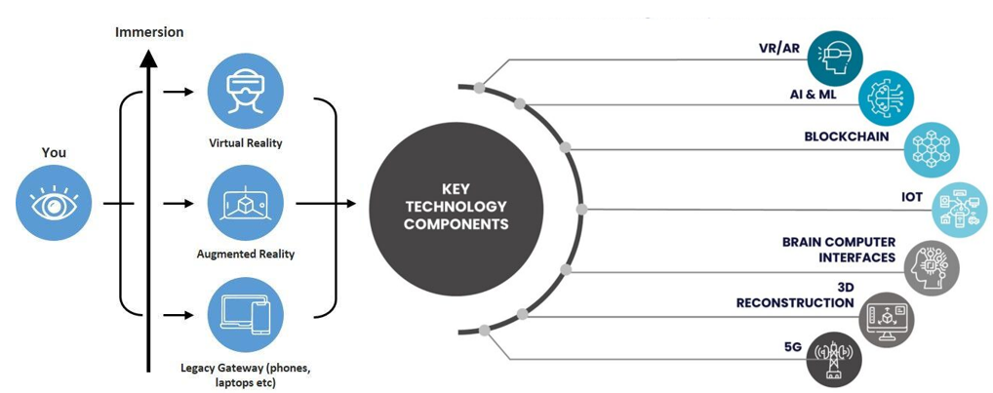
Figure 1. Depiction of Real and Virtual World Integration in the Metaverse. Source: Authors

2.3 Impact of User Behaviours on Brand Engagement in Virtual Environments
User behaviours purchasing NFTs, social interaction, attending virtual events and creating content are central to brand engagement in immersive ecosystems, shaping perceptions, fostering emotional bonds and driving loyalty (Shamim et al., 2025; Bilgihan et al., 2024; Lee and Shen, 2024).
Branded NFTs enable digital self-expression, exclusivity and identity construction; owning unique avatars, wearables and collectibles strengthens emotional attachment (Xie and Muralidharan, 2023; Simonetti et al., 2025). Scarcity and perceived investment value further enhance brand attitudes, amplified by social-comparison dynamics (Wang et al., 2024; Chang et al., 2024; Xie et al., 2024).
Social interactions reinforce engagement, with brand communities fostering trust, knowledge-sharing and purchase intention, while avatar-based interactivity enhances belonging and loyalty (Agnihotri et al., 2024; Kumar and Shankar, 2024; Payal et al., 2024).
Virtual events and gamified rewards build trust, satisfaction and loyalty, especially among Gen Z (Habachi et al., 2024), and participatory content creation enhances ownership and advocacy (Bilgihan et al., 2024; Xu et al., 2024).

2.4 Impact of user engagement and experience on brand success in virtual environments
User engagement and experience are pivotal drivers of brand success. Wiertz and De Ruyter (2007) showed that contributions to firm-hosted online communities enhance brand success, with knowledge-sharing a critical engagement mechanism.
Brands must actively facilitate interaction to elevate engagement (Huang and Benyoucef, 2013), and cultural dynamics matter: holistic thinkers evaluate brand extensions more favourably in virtual settings (Su et al., 2021).
Social media is integral to engagement, with higher social identification and interactivity increasing engagement with branded content (Hsieh and Tsao, 2019).
Theoretically, Brodie et al. (2011) position engagement as active participation in brand experiences, and purchase intentions in virtual communities often serve social and self-identity fulfilment, framing engagement as a pathway to loyalty.

- Theoretical Foundation
3.1 Flow theory
Flow Theory (Csikszentmihalyi, 1990) provides a valuable framework for assessing metaverse engagement. Flow is a state of deep immersion and focused attention marked by high intrinsic motivation and enjoyment, particularly relevant where engagement determines brand success. Recent work extends it to virtual and augmented reality: in game-based metaverses, perceived enjoyment enhances flow, contributing to satisfaction and continued use (Hyeon and Lee, 2025).
Contemporary research links flow to virtual brand experiences: authenticity, interactivity and entertainment enhance flow in live streaming, with interactivity most influential (Wu et al., 2024); technological factors drive flow in emerging-market metaverse use (Liang et al., 2024); flow induces subjective time acceleration in VR (Rutrecht et al., 2021); and flow shapes participative and sharing behaviours (Lo and Lai, 2023). Accordingly, our survey incorporated flow elements clear goals, immediate feedback and challenge-skill balance, asking users to self-report flow during metaverse interactions.

  - Self-Determination Theory (SDT)
Self-Determination Theory (SDT) holds that motivation and well-being are greatest when three innate needs are met: autonomy (volitional choice), competence (feeling effective) and relatedness (feeling connected) (Deci and Ryan, 2000). In digital environments, SDT explains how intrinsic motivation to explore, master and connect drives deeper engagement.
Flow Theory and SDT are complementary: flow captures moment-to-moment immersion when challenge-skill balance, clear goals and feedback align (Csikszentmihalyi, 1990), while SDT explains why users enter and remain in flow autonomy supports exploration, competence drives mastery, and relatedness sustains social interaction through avatars. Together they explain the immersion and need satisfaction underpinning engagement, satisfaction and loyalty.
3.3 Constructs and Hypotheses
The study examines four constructs. User engagement (UE) is the cognitive, emotional and behavioural involvement a user has with a brand during metaverse interactions. User experience (UX) is the perceived quality of interaction, encompassing immersion, usability, enjoyment and presence. Brand satisfaction (BSAT) is the user’s overall evaluation of the brand from metaverse encounters. Brand success (BSUC) refers to brand-relevant outcomes: continuance intention, purchase intention, advocacy and word of mouth. The SDT needs and Flow dimensions are treated as underlying psychological mechanisms, not separately measured constructs.
Flow Theory and SDT jointly imply that immersive, need-satisfying interactions raise engagement and experience, shaping satisfaction and brand outcomes. We therefore expect higher user engagement to be positively associated with brand success (H1) and higher user experience quality to be positively associated with brand success (H2). Because satisfaction summarises cumulative evaluations, we expect brand satisfaction to mediate the engagement/experience–success relationships (H3). Consistent with a configurational view, high brand success may arise from multiple sufficient configurations rather than any single necessary condition (P1).

4. Methodology
4.1 Fuzzy set Qualitative Comparative Analysis and its Application to the study
Fuzzy-set Qualitative Comparative Analysis (fsQCA) offers a mixed-method framework for examining complex causal configurations in branding (Jia et al., 2022). Positioned between exploratory and hypothesis-testing strategies, it identifies how combinations of conditions present or absent jointly produce an outcome, highlighting equifinality (Schneider and Wagemann, 2012), and is valuable in small-N research (Ragin, 2008).
The fsQCA process comprises six stages: case selection, identification of causal conditions, calibration of membership scores, truth-table construction, logical minimisation, and robustness checks via consistency and coverage. Figure 2 illustrates this flow. Boolean minimisation derives minimal sufficient combinations, revealing causal complexity beyond single-variable effects.
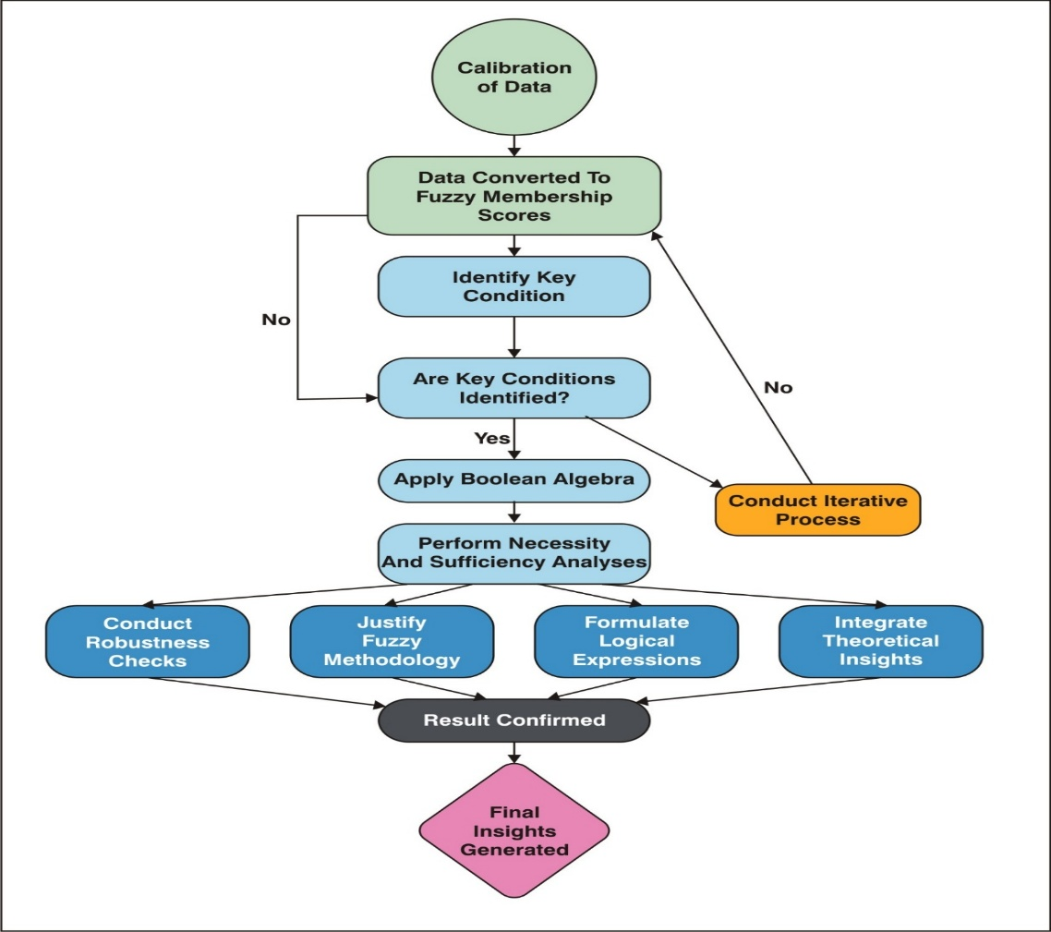
Figure 2. Flowchart illustrating the steps involved in the fuzzy set qualitative comparative analysis (FsQCA) methodology, from data calibration to the generation of final insights.

4.2 Identification and selection of variables
Variable selection followed a structured three-stage process. First, a literature review identified consistently validated variables satisfaction, interaction frequency, perceived brand impact, emotional connection and personalisation as core indicators (Cadet and Chainay, 2020; Lu and Lau, 2025).
Second, interviews and focus groups provided nuanced understanding of involvement, satisfaction drivers and brand-success perceptions, refining the variables. Third, surveys captured UE, UX, BSAT and BSUC (Table 2), with immersiveness measured via presence scales, sociability via social and co-presence, and ecological faithfulness via authenticity measures (Cadet and Chainay, 2020; Poeschl and Doering, 2015; Lu and Lau, 2025).
Only constructs with strong conceptual grounding and proven reliability were retained, and a pilot study validated clarity and reliability before full-scale administration.

4.3 Measures
All constructs were measured on seven-point Likert scales anchored from 1 (strongly disagree) to 7 (strongly agree). The ten-item engagement and experience scales are adapted subsets. Full measurement items, together with their adapted sources, are provided in Appendix Table 1.

4.4 Platforms Studied and Metaverse Activities
The study focused on prominent platforms Roblox, Decentraland and The Sandbox selected for their adoption, functionality and capacity to host brand interactions. Roblox, known for user-generated content and social gaming, hosts branded experiences such as Nike’s Nikeland (Bilgihan et al., 2024); Decentraland, built on blockchain, enables virtual land purchase, NFT trading and community events (Brouard, 2024).
The Sandbox supports voxel-based creation and monetisation, used by brands such as Adidas (Brandes and Dölp, 2025). Across platforms, four activity types were considered: trading digital assets, attending virtual events, avatar-based social interaction, and designing digital assets or experiences (Lee and Shen, 2024; Hennig-Thurau et al., 2023).

4.5 Data Collection
Data were collected using stratified random sampling. From a frame of adults (18+) active on at least one platform with prior brand-related metaverse experience, 600 eligible users were invited at random, stratified by primary activity (gaming, NFT trading, social interaction, content creation and virtual events). Of these, 312 provided complete, consenting responses a 52% response rate with balanced representation, measured on validated UE, UX, BSAT and BSUC scales.
India offers a theoretically and empirically justified context: one of the world’s fastest-growing metaverse markets (USD 2 billion in 2023, projected to grow at a robust CAGR through 2030), with a large, digitally native youth population (median age 28), rapid 5G expansion and high mobile-first penetration (Verma, 2024; Statista, 2025; Dwivedi et al., 2023). Indian consumers’ receptivity to avatar-based self-expression and NFT ownership makes it particularly relevant, and focusing on this underexplored, non-Western market broadens the theoretical reach and generalisability of the findings (Payal et al., 2024).

5. Data Analysis and Results
5.1. Sample Profile
Descriptive analysis (IBM SPSS 25.0) profiled the 312 respondents (Table 1): 46% men (143) and 54% women (169), distributed across age bands from 18 to 45, with the largest group aged 23–28 (24.04%).
Regarding metaverse engagement, 60.58% used the metaverse frequently (several times weekly); 45.19% participated in NFT trading, 52.56% in social interaction or content creation, and 41.35% in virtual events, underscoring these activities’ role in brand engagement.

Table 1: Demographic and Metaverse Engagement Details of Respondents (N = 312)
Participants' Information | No. of Participants | % | Participants' Information | No. of Participants | %
Gender |  |  | Metaverse Engagement Frequency
Male | 143 | 46.00 | Daily | 52 | 16.67
Female | 169 | 54.00 | Several times a week | 98 | 31.41
 |  |  | Weekly | 73 | 23.38
Age (Years) |  |  | Monthly | 54 | 17.31
18–22 | 64 | 20.51 | Rarely | 35 | 11.21
23–28 | 75 | 24.04
29–34 | 60 | 19.23 | NFT Interaction
35–41 | 57 | 18.27 | Yes | 141 | 45.19
42–45 | 56 | 17.95 | No | 171 | 54.81
Marital Status |  |  | Virtual Event Participation
Single | 107 | 34.29 | Yes | 129 | 41.35
Married with children | 84 | 26.93 | No | 183 | 58.65
Married without children | 121 | 38.78 | Social Interaction/Content Creation
 |  |  | Yes | 164 | 52.56
Occupation |  |  | No | 148 | 47.44
Students | 88 | 28.21 | Monthly Family Income
Job | 102 | 32.69 | INR 30,000 or less | 57 | 18.40
Business | 122 | 39.10 | INR 30,001–50,000 | 80 | 25.64
 |  |  | INR 50,001–80,000 | 100 | 32.05
 |  |  | INR 80,001 and above | 75 | 23.91
Source: Authors

5.2. Assessment of Reliability and validity
PLS-SEM confirmed satisfactory reliability and consistency. The measurement model was evaluated via standardized loadings, Cronbach’s α, composite reliability (CR) and average variance extracted (AVE). Standardized loadings ranged 0.699–0.741 (Brand Satisfaction), 0.670–0.707 (User Engagement), 0.677–0.714 (User Experience) and 0.661–0.682 (Brand Success), all exceeding the 0.60 minimum with significant z-values (p < .001) (Bagozzi and Yi, 1988; Table 2).
Cronbach’s α and CR were 0.84 (BSAT), 0.90 (UE), 0.90 (UX) and 0.77 (BSUC), all above the 0.70 minimum (Nunnally and Bernstein, 1994; Hair et al., 2019), indicating that items consistently measure their constructs.
For convergent validity, all loadings were positive and significant (p < .001) and CR ranged 0.77–0.90 (Table 2). AVE values were 0.51 (BSAT), 0.48 (UE), 0.48 (UX) and 0.45 (BSUC); although three fell marginally below 0.50, convergent validity holds given the significant loadings and adequate CR (Fornell and Larcker, 1981).
Common method bias was assessed with Harman’s single-factor test (Podsakoff et al., 2003): one unrotated factor explained 31.4% of variance, below 50%. Procedural remedies anonymity, no right/wrong answers, and separation of predictor and criterion items further limited bias, though it cannot be entirely ruled out in cross-sectional self-report data.
Discriminant validity used the Heterotrait–Monotrait (HTMT) ratio (Hair et al., 2019; Henseler et al., 2015). All HTMT values fell below the 0.85 threshold (maximum 0.814 for the engagement–experience pair; Table 2a), confirming each construct is empirically distinct. Together with the Harman result, neither method bias nor poor discriminant validity threatens the conclusions.

Table 2. Reliability Statistics
Factor Loadings
Factor | Indicator | Estimate | Cronbach’s Alpha | AVE | SE | Z | p
Brand Satisfaction | BSAT_1 | 0.705 | 0.841 | 0.514 | 0.0323 | 21.8 | <.001
 | BSAT_2 | 0.741 |  |  | 0.0337 | 22.0 | <.001
 | BSAT_3 | 0.721 |  |  | 0.0328 | 21.9 | <.001
 | BSAT_4 | 0.719 |  |  | 0.0335 | 21.5 | <.001
 | BSAT_5 | 0.699 |  |  | 0.0328 | 21.3 | <.001
User Engagement | UE_1 | 0.684 | 0.903 | 0.481 | 0.0322 | 21.3 | <.001
 | UE_2 | 0.696 |  |  | 0.0325 | 21.4 | <.001
 | UE_3 | 0.706 |  |  | 0.0325 | 21.7 | <.001
 | UE_4 | 0.684 |  |  | 0.0334 | 20.5 | <.001
 | UE_5 | 0.698 |  |  | 0.0327 | 21.3 | <.001
 | UE_6 | 0.705 |  |  | 0.0325 | 21.7 | <.001
 | UE_7 | 0.677 |  |  | 0.0323 | 20.9 | <.001
 | UE_8 | 0.707 |  |  | 0.0326 | 21.7 | <.001
 | UE_9 | 0.670 |  |  | 0.0311 | 21.5 | <.001
 | UE_10 | 0.706 |  |  | 0.0325 | 21.7 | <.001
User Experience | UX_1 | 0.690 | 0.902 | 0.481 | 0.0327 | 21.1 | <.001
 | UX_2 | 0.681 |  |  | 0.0319 | 21.3 | <.001
 | UX_3 | 0.714 |  |  | 0.0325 | 22.0 | <.001
 | UX_4 | 0.694 |  |  | 0.0326 | 21.3 | <.001
 | UX_5 | 0.678 |  |  | 0.0317 | 21.4 | <.001
 | UX_6 | 0.706 |  |  | 0.0328 | 21.5 | <.001
 | UX_7 | 0.687 |  |  | 0.0317 | 21.7 | <.001
 | UX_8 | 0.677 |  |  | 0.0320 | 21.1 | <.001
 | UX_9 | 0.703 |  |  | 0.0319 | 22.0 | <.001
 | UX_10 | 0.702 |  |  | 0.0321 | 21.9 | <.001
Brand Success | BSUC_1 | 0.661 | 0.765 | 0.448 | 0.0308 | 21.5 | <.001
 | BSUC_2 | 0.662 |  | 0.448 | 0.0314 | 21.1 | <.001
 | BSUC_3 | 0.673 |  | 0.448 | 0.0313 | 21.5 | <.001
 | BSUC_4 | 0.682 |  | 0.448 | 0.0317 | 21.5 | <.001

UE: User Engagement, UX: User Experience, BSAT: Brand Satisfaction, BSUC: Brand Success
Source: Authors
Table 2a. Heterotrait–Monotrait (HTMT) Ratio Matrix
Construct | BSAT | BSUC | UX | UE
Brand Satisfaction (BSAT)
Brand Success (BSUC) | 0.743
User Experience (UX) | 0.768 | 0.712
User Engagement (UE) | 0.756 | 0.729 | 0.814

Note: All HTMT values below 0.85 confirm discriminant validity. BSAT = Brand Satisfaction; BSUC = Brand Success; UX = User Experience; UE = User Engagement. Values derived from SmartPLS 4.1 bootstrapping procedure (5,000 subsamples). Source: Authors.
Figure 3 presents the Pearson correlation matrix (Jamovi), depicting inter-item relationships across the BSAT, UE, UX and BSUC items on a colour gradient from strong positive to strong negative correlations.
All standardized loadings were positive and significant, and the heatmaps (panels a–d) show significant positive inter-item correlations within each construct, consistent with unidimensionality; none approached the 0.95 multicollinearity ceiling.
The square root of AVE (0.72 BSAT, 0.69 UE, 0.69 UX, 0.67 BSUC) is close to the construct intercorrelations, reflecting conceptual proximity; discriminant validity is therefore established primarily through HTMT (Table 2a), all ratios below 0.85.
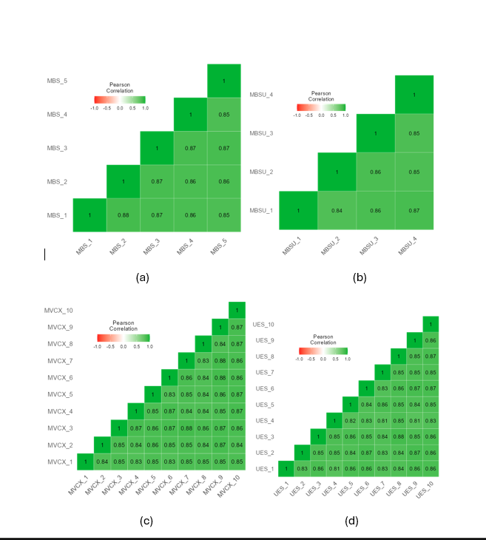
Figure 3. Correlation Heatmap Obtained using Jamovi Software.
Pearson correlation heatmaps for measurement items: (a) Brand Satisfaction (BSAT_1 to BSAT_5), (b) Brand Success (BSUC_1 to BSUC_4), (c) User Experience (UX_1 to UX_10), and (d) User Engagement (UE_1 to UE_10), illustrating positive inter-item correlations within each construct.
Source: Authors.

5.3. Data Analysis using FsQCA
5.3.1. Data Driven Results from FsQCA
To analyse UE, UX, BSAT and BSUC, raw responses were calibrated (Ragin, 2008) into fuzzy-set membership scores expressing each case’s degree of belonging to a condition and to the outcome.
Calibration used three anchors: the 95th percentile for full membership (0.95), the 50th as the crossover point (0.50), and the 5th for full non-membership (0.05), bounding scores between 0 and 1 (Ragin, 2008; Douglas et al., 2020). This common scale enables comparison of the calibrated UE, UX, BSAT and BSUC values (Table 3).

Table 3. Intermediate Solution
Model: BSUC = f (BSAT, UX, UE) | Raw coverage | Unique coverage | consistency
BSAT x UX | 0.208 | 0.036 | 0.650
BSAT x UE | 0.241 | 0.069 | 0.669
UX x UE | 0.219 | 0.046 | 0.600
User Experience (UX), User Engagement (UE), Brand Satisfaction (BSAT), and Brand Success (BSUC)
Note: solution coverage: 0.323827; solution consistency: 0.756327 Source: Authors

As shown in Table 3, the intermediate solution models BSUC = f(BSAT, UX, UE). Raw coverage is about 20.84% for BSAT × UX, 24.15% for BSAT × UE and 21.90% for UX × UE; unique coverage is 3.59%, 6.90% and 4.65% respectively.
Consistency indicates sufficiency (Table 4): 0.650 (BSAT × UX), 0.669 (BSAT × UE) and 0.600 (UX × UE). For the overall intermediate solution, coverage is 0.324 (about 32% of the outcome) and consistency 0.756.
Figure 4 presents the framework for brand success, illustrating the proposed relationships among UX, UE, BSAT and BSUC in the metaverse.
In the model, UX, UE and BSAT are the antecedent conditions for BSUC; the subset–superset analysis evaluates which combinations are jointly sufficient for high brand success rather than estimating a single directional path, grounding the conceptual model in the empirical configurations.
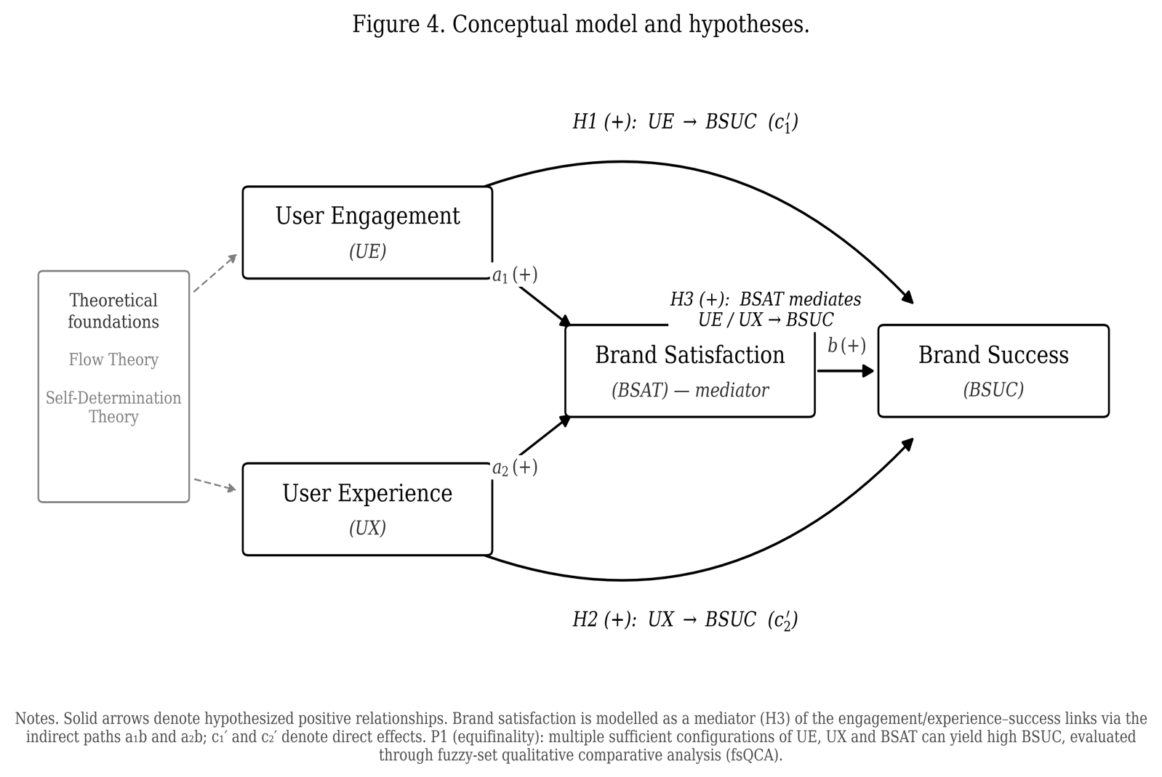
Figure 4. Conceptual model and hypotheses (H1–H3): user engagement (UE) and user experience (UX) as antecedents, brand satisfaction (BSAT) as mediator, and brand success (BSUC) as the outcome, framed by Flow Theory and Self-Determination Theory.
Source: Authors

Table 4. Subset/Superset Analysis
BSUC = f (BSAT, UX, UE) | Consistency | Raw Coverage | Combined
BSAT * UX * UE | 0.713 | 0.172 | 0.305
BSAT * UX | 0.650 | 0.208 | 0.246
UX * UE | 0.600 | 0.219 | 0.181
BSAT * UE | 0.669 | 0.241 | 0.295
UX | 0.362 | 0.349 | 0.084
BSAT | 0.410 | 0.368 | 0.086
UE | 0.373 | 0.349 | 0.084
User Experience (UX), User Engagement (UE), Brand Satisfaction (BSAT), and Brand Success (BSUC)
Source: Authors

Table 5. Configuration Analysis for High Brand Success (BSUC) in the Metaverse
Configuration | 1 | 2 | 3
Causal Conditions
BSAT (Brand Satisfaction) | ● | ●
UX (User Experience) | ● |  | ●
UE (User Engagement) |  | ● | ●
Performance Metrics
Raw Coverage | 0.208 | 0.241 | 0.218
Unique Coverage | 0.036 | 0.069 | 0.047
Consistency | 0.650 | 0.669 | 0.6
Overall Solution | Coverage: 0.324 | Consistency: 0.756
Note: Key: ● = Core condition present (essential for outcome), Blank = "Don't care" (condition irrelevant for configuration), User Experience (UX), User Engagement (UE), Brand Satisfaction (BSAT), and Brand Success (BSUC) (Outcome variable)

Table 6. Configuration Analysis for High Brand Success (BSUC) – Expanded Subset–Superset Configurations in the Metaverse
Configuration Type | Triple Path (BSAT+UX+UE) | Satisfaction + Experience | Experience + Engagement | Satisfaction + Engagement
Configuration | A | B | C | D
BSAT (Brand Satisfaction) | ● | ● | ● | ●
UX (User Experience) | ● | ● |  | ●
UE (User Engagement) | ● | ● | ●
Raw Coverage | 0.172 | 0.208 | 0.219 | 0.241
Consistency | 0.713 | 0.65 | 0.6 | 0.669
Combined Coverage | 0.305 | 0.246 | 0.181 | 0.295
Note: Key: ● = Core condition present (essential for outcome), Blank = "Don't care" (condition irrelevant for configuration), User Experience (UX), User Engagement (UE), Brand Satisfaction (BSAT), and Brand Success (BSUC) (Outcome variable)

Drawing on Tables 5 and 6, the analysis underscores equifinality: multiple distinct paths lead to the same outcome (Ragin, 2008). No single factor BSAT, UX or UE is necessary alone; their interaction drives brand outcomes in immersive digital environments.
Table 5 presents three core configurations for high BSUC. Configuration 1 (BSAT + UX) shows brand success even without strong engagement, as satisfied users with positive immersive experiences form lasting relationships (Bilgihan et al., 2024). Configuration 2 (BSAT + UE) highlights satisfaction with active participation, enhancing loyalty and advocacy (Hollebeek et al., 2022). Configuration 3 (UX + UE) indicates that even without reported satisfaction, immersive interactive environments yield favourable outcomes, supporting Flow Theory (Csikszentmihalyi, 1990).
Table 6 expands these via subset–superset analysis. Configuration A, the “Triple Path” (BSAT, UX, UE), shows the highest combined coverage (0.305): satisfied, engaged and immersed users maximise brand success, aligning with service-dominant logic and value co-creation.
Other configurations show versatility: B (BSAT + UX) and D (BSAT + UE) reaffirm satisfaction combined with either experience or engagement, letting brands tailor strategies; C (UX + UE), despite lower consistency, validates immersive participatory experiences even without explicit satisfaction (Shin, 2019).
5.3.2. Necessity Analysis
The necessity analysis tests whether any single condition must be present; a condition is necessary only when its consistency exceeds 0.90 (Schneider and Wagemann, 2012). No condition met this: UE, UX and BSAT recorded single-condition consistency of 0.373, 0.362 and 0.410 respectively. High brand success thus arises from combinations, not any single necessary condition, motivating the sufficiency analysis.

5.3.3. Sufficiency Analysis
The sufficiency analysis identifies jointly sufficient configurations. UE, UX and BSAT were entered into the truth table with consistency and frequency thresholds applied (Ragin, 2008; Schneider and Wagemann, 2012). As reported in Tables 5 and 6, brand satisfaction is present in every high-consistency sufficient path, while engagement and experience contribute in combination rather than in isolation.
The three sufficient configurations align with prior evidence. BSAT × UX records high coverage and consistency: satisfied users enjoying well-designed experiences remain loyal and recommend the brand. BSAT × UE is likewise favourable, consistent with engagement–loyalty links (Jeong and Kim, 2019) and social-media effects on customer equity (Ebrahim, 2020). UX × UE contributes with slightly lower consistency, reflecting the interplay of experience and engagement central to brand success in immersive settings.
User engagement here is multifaceted spanning asset trading, event attendance, social interaction and content creation reflecting psychological, social and experiential motivations captured through the UE and UX constructs rather than platform-specific variables.

5.4 Structural Model and Hypothesis Evaluation
Because fsQCA tests sufficiency rather than net linear effects, hypotheses are evaluated configurationally (Table 7). Consistent with the necessity result, user engagement (single-condition consistency 0.373) and user experience (0.362) are not sufficient alone; they support brand success only in combination, supporting H1 and H2 within sufficient configurations. Brand satisfaction appears in every high-consistency path the triadic BSAT × UX × UE (0.713), BSAT × UE (0.669) and BSAT × UX (0.650) and shows the highest single-condition consistency (0.410), indicating a central, mediation-consistent role supporting H3. A formal bootstrap mediation test is recommended as a complement.
Table 7. Hypothesis Evaluation Based on fsQCA Sufficiency Analysis. Source: Authors, from configurational results reported in Tables 5 and 6.

Hypothesis | Configurational evidence (fsQCA) | Key values | Outcome
H1: User engagement (UE) → brand success (BSUC) | UE not sufficient alone; sufficient in BSAT×UE and UX×UE | UE alone consistency 0.373; BSAT×UE 0.669; UX×UE 0.600 | Supported within configurations
H2: User experience (UX) → brand success (BSUC) | UX not sufficient alone; sufficient in BSAT×UX and triadic path | UX alone consistency 0.362; BSAT×UX 0.650; triadic 0.713 | Supported within configurations
H3: Brand satisfaction (BSAT) mediates UE/UX → BSUC | BSAT present in all high-consistency sufficient paths; highest single-condition consistency | Triadic 0.713; BSAT×UE 0.669; BSAT×UX 0.650; BSAT alone 0.410 | Supported (configurationally); SEM mediation test recommended
Overall solution | Three sufficient configurations (equifinality) | Solution coverage 0.324; solution consistency 0.756

6. Discussion
The fsQCA findings clarify how combinations of UE, UX and BSAT contribute to brand success in the metaverse, identifying key pathways to favourable outcomes.
BSAT × UX emerged as a significant configuration (consistency 0.650, raw coverage 20.84%): satisfied users perceiving high-quality immersive experiences develop loyalty and advocacy, consistent with prior work on satisfaction, experience and emotional connection (Thaichon et al., 2022; Bilgihan et al., 2024). Brands should prioritise seamless immersive experiences while addressing ethical concerns such as data-privacy risks and excessive use.
BSAT × UE showed a strong association (consistency 0.669, coverage 24.15%): active participation with high satisfaction enhances outcomes, echoing engagement–equity links (Jeong and Kim, 2019). Brands should encourage gamified and co-creation activities that deepen involvement while sustaining satisfaction.
UX × UE, though slightly lower in consistency (0.600, coverage 21.90%), shows engagement is most effective when paired with high-quality experience even where satisfaction is not dominant, consistent with Flow Theory’s challenge–skill balance (Csikszentmihalyi, 1990; Shin, 2019).
Individual factors showed lower consistency than their combinations, emphasising holistic strategies: BSAT × UX × UE achieved the highest consistency (0.713), reinforcing Flow Theory’s premise that optimal engagement arises from a balance between challenge and skill in immersive environments (Csikszentmihalyi, 1990).

7. Implications
7.1 Theoretical Contributions
This research integrates SDT and Flow Theory within immersive, digitally mediated environments characterised by persistent communities, avatar-based identity and interactive interfaces, clarifying how psychological needs and experiential states jointly shape engagement, satisfaction and brand outcomes. Unlike earlier applications in traditional or gamified settings, metaverse interactions involve a distinctive interplay of intrinsic motivation and experiential absorption, extending both theories into co-created domains.
Within SDT, autonomy, competence and relatedness take distinctive forms: autonomy through customisable avatars and digital-asset ownership, competence through skill-based challenges and achievement, and relatedness through persistent social interaction in branded communities (Bilgihan et al., 2024). These are advanced as conceptual mechanisms underlying engagement and experience rather than separately measured effects.
Flow Theory is extended by proposing that experiential immersion depends on aligning task challenge and user skill, calibrated by digital affordances and interaction design (Zhong and Hamouda, 2024); gamified missions and event-based interactions act as flow facilitators. Consistent with our findings, deep immersive engagement can yield favourable outcomes even when satisfaction is not the dominant condition.
Collectively, the study advances marketing and psychological theory by suggesting that the confluence of need satisfaction and experiential immersion is associated with engagement, satisfaction and brand performance, extending SDT and Flow Theory into co-created digital domains while distinguishing tested associations from theoretical interpretation.

7.2. Managerial Implications
User experience is a key determinant of both satisfaction and favourable outcomes, appearing consistently in the configurations associated with success. Crafting engaging, interactive and personalised metaverse experiences is therefore central to sustaining engagement and long-term brand success.
Brands should create immersive experiences connected to users’ virtual identities. Personalisation customisable avatars and interactive environments lets users express identity and strengthens presence, reinforcing the emotional bond. Aligning a brand’s virtual presence with users’ self-concept cultivates connection; tailored experiences deepen engagement, loyalty and advocacy (Thaichon et al., 2022; Xie and Muralidharan, 2023).
Frequently discussed features such as NFT interoperability, smart contracts and rarity dynamics may strengthen exclusivity and trust, but were not measured here and are presented as future avenues rather than findings; the evidence speaks to combinations of engagement, experience and satisfaction, not blockchain-specific mechanisms.
The results show synergy between satisfaction and engagement: combining participation with high satisfaction strengthens equity and loyalty (Jeong and Kim, 2019). Managers should build gamified, co-creation and reward opportunities that deepen involvement, as users’ sense of ownership reinforces attachment and long-term loyalty.
Overall, user experience is central to both satisfaction and success: to remain competitive, brands must ensure immersive experiences are emotionally resonant, consistent and aligned with users’ values and identities (Jung and Pawlowski, 2014); functional or visually appealing assets are no longer sufficient. Those delivering high-quality interactive experiences build lasting engagement, loyalty and competitive advantage.

8. Limitations and Future Scope
This study has several limitations. First, the sample of 312 active, experienced users, while ensuring expertise, may bias results toward highly engaged participants and underrepresents casual or novice users, limiting generalisability; a more diverse and representative sampling frame is needed.
Second, inclusion/exclusion decisions may have overlooked relevant factors, and the absence of a control group limits causal attribution. While effective for complex causal analysis, fsQCA’s small-N, qualitative orientation reduces robustness relative to larger quantitative models and limits methodological triangulation.
Third, the cross-sectional design precludes analysis of how engagement and experience evolve; longitudinal studies are needed to assess the sustainability of engagement. Ethical implications privacy, addiction, cyberbullying and exploitation remain underexplored, and future work should develop safeguards for user well-being.
Finally, as several large technology firms have scaled back metaverse investments, we frame our contribution conservatively: the findings speak most directly to brands active on large, metaverse-like platforms game-based worlds such as Roblox and Fortnite and social virtual reality and to the design of future immersive environments. We position avatar-mediated branding as an evolving phenomenon whose psychological mechanisms engagement, experience and satisfaction are likely to persist across successive technological forms.

Acknowledgement:

The author(s) acknowledge the use of generative AI tools to enhance the linguistic quality and readability of this manuscript. These tools were employed solely to improve spelling, grammar, and overall clarity, based on the original content created by the author(s). The author(s) take full responsibility for the original content, interpretations, and conclusions presented in this work.

Funding: This research received no specific grant from any funding agency in the public, commercial, or not-for-profit sectors.
Conflicts of Interest: The authors declare no conflicts of interest.

Appendix Table 1. Measurement Items

The following items were administered to measure each construct, adapted to the metaverse branding context from the cited sources. All items used seven-point Likert scales anchored from 1 (strongly disagree) to 7 (strongly agree). Item codes correspond to the standardized loadings reported in Table 2.
Construct (source) | Code | Item wording (adapted)
User Engagement (UE) adapted from O’Brien and Toms (2010) | UE_1 | I lost track of myself in the brand’s metaverse experience.
 | UE_2 | The time I spent in the brand’s metaverse space slipped away.
 | UE_3 | I was absorbed in what I was doing in the brand’s metaverse space.
 | UE_4 | I felt involved in the brand’s metaverse activities.
 | UE_5 | The brand’s metaverse experience was fun.
 | UE_6 | I was motivated to keep interacting with the brand in the metaverse.
 | UE_7 | I would recommend the brand’s metaverse experience to others.
 | UE_8 | Interacting with the brand in the metaverse was worthwhile.
 | UE_9 | I felt interested in the brand’s metaverse activities.
 | UE_10 | I would return to the brand’s metaverse space.
User Experience (UX) adapted from O’Brien and Toms (2010); Basu et al. (2024); Cadet and Chainay (2020) | UX_1 | The brand’s metaverse environment was easy to use.
 | UX_2 | It was easy to navigate the brand’s metaverse space.
 | UX_3 | The brand’s metaverse environment was visually appealing.
 | UX_4 | The brand’s metaverse space was aesthetically pleasing.
 | UX_5 | I felt present in the brand’s metaverse environment.
 | UX_6 | The brand’s metaverse environment felt realistic.
 | UX_7 | The sensory quality (visuals and sound) of the experience was high.
 | UX_8 | The experience responded smoothly to my actions.
 | UX_9 | I felt immersed in the brand’s metaverse environment.
 | UX_10 | Overall, the brand’s metaverse experience was of high quality.
Brand Satisfaction (BSAT) adapted from Fornell et al. (1996) | BSAT_1 | Overall, I am satisfied with the brand’s presence in the metaverse.
 | BSAT_2 | The brand’s metaverse experience met my expectations.
 | BSAT_3 | The brand’s metaverse experience came close to my ideal.
 | BSAT_4 | I am pleased with my experience of the brand in the metaverse.
 | BSAT_5 | The brand’s metaverse offering was satisfactory.
Brand Success (BSUC) developed for this study, drawing on Mathwick et al. (2008) | BSUC_1 | This brand stands out from competitors in the metaverse.
 | BSUC_2 | I would choose this brand over others because of its metaverse presence.
 | BSUC_3 | I would speak positively about this brand to others.
 | BSUC_4 | The brand has a competitive advantage in the metaverse.
References
Agnihotri, D., Chaturvedi, P., Swarup, K., Mathur, A., Tripathi, V., and Singh, N. (2024). Does social presence drive customer brand engagement and purchase intention in the fashion retail metaverse? The moderating role of self-efficacy. Internet Research. https://doi.org/10.1108/intr-01-2024-0030
Agnihotri, R. (2020). Social media, customer engagement, and sales organizations: A research agenda. Industrial Marketing Management, 90, 291-299.
Alshater, M. M., Nasrallah, N., Khoury, R., and Joshipura, M. (2024). Deciphering the world of NFTs: a scholarly review of trends, challenges, and opportunities. Electronic Commerce Research, 1-57.
Anderson, K. C., Hansen, H., and Laverie, D. (2024). Technology has Agency too! Disentangling Technology's Causal and Structural Agency in a Service System. Journal of Macromarketing, 44(2), 510-533.
Arya, V., Paul, J., and Sethi, D. (2022). Like it or not! Brand communication on social networking sites triggers consumer‐based brand equity. International Journal of Consumer Studies, 46(4), 1381-1398.
Arya, V., Sambyal, R., Sharma, A., and Dwivedi, Y. K. (2024a). Brands are calling your AVATAR in Metaverse–A study to explore XR‐based gamification marketing activities and consumer‐based brand equity in virtual world. Journal of Consumer Behaviour, 23(2), 556-585.
Arya, V., Sethi, D., and Hollebeek, L. D. (2024b). Using augmented reality to strengthen consumer/brand relationships: the case of luxury brands. Journal of Consumer Behaviour. https://doi.org/10.1002/cb.2419
Basu, B., Kar, A. K., and Sen, S. (2024). Antecedents of user experience in the immersive Metaverse ecosystem: Insights from mining user reviews. Communications of the Association for Information Systems, 55(1), 13.
Bilgihan, A., Leong, A. M. W., Okumus, F., and Bai, J. (2024). Proposing a metaverse engagement model for brand development. Journal of Retailing and Consumer Services, 78, 103781.
Blazquez, M. (2024). The Metaverse and its potential for digital sustainability in fashion. Journal of Global Fashion Marketing, 15(3), 303-319.
Brandes, L., and Dölp, K. (2025). Non-Fungible Tokens (NFTs) as Digital Brand Extensions: Evidence on Financial Performance and Parent-Brand Spillovers. International Journal of Research in Marketing. https://doi.org/10.1016/j.ijresmar.2025.01.001
Brodie, R. J., Hollebeek, L. D., Jurić, B., and Ilić, A. (2011). Customer Engagement: Conceptual Domain, Fundamental Propositions, and Implications for Research. Journal of Service Research, 14(3), 252-271.
Brouard, M. (2024). Setting sail in a tokenized world: an exploration of the Bored Ape Yacht club and the co-created consumer experience. International Journal of Research in Marketing. https://doi.org/10.1016/j.ijresmar.2024.03.002
Buhalis, D., Leung, D., and Lin, M. (2023). Metaverse as a disruptive technology revolutionising tourism management and marketing. Tourism management, 97, 104724.
Cadet, L. B., and Chainay, H. (2020). Memory of virtual experiences: Role of immersion, emotion and sense of presence. International Journal of Human-Computer Studies, 144, 102506.
Chandra, S., Verma, S., Lim, W. M., Kumar, S., and Donthu, N. (2022). Personalization In Personalized Marketing: Trends and Ways Forward. Psychology and Marketing, 39(8), 1529-1562.
Chang, C. W., Lai, C. J., and Yen, C. C. (2024). Examining drivers of NFT purchase intention: The impact of perceived scarcity and risk. Acta Psychologica, 248, 104424.
Corne, A., Massot, V., and Merasli, S. (2023). The determinants of the adoption of blockchain technology in the tourism sector and metaverse perspectives. Information Technology and Tourism, 25(4), 605-633.
Csikszentmihalyi, M., Montijo, M. N., and Mouton, A. R. (2018). Flow theory: Optimizing elite performance in the creative realm. In S. I. Pfeiffer, E. Shaunessy-Dedrick, and M. Foley-Nicpon (Eds.), APA handbook of giftedness and talent (pp. 215–229). American Psychological Association.
Csikszentmihalyi, Mihaly. (1990). Flow: The Psychology of Optimal Experience. Journal of Leisure Research, 24(1), pp. 93–94
Daassi, M., and Debbabi, S. (2021). Intention to reuse AR-based apps: The combined role of the sense of immersion, product presence and perceived realism. Information and Management, 58(4), 103453.
Deci, E. L., and Ryan, R. M. (2000). The “What” and “Why” of Goal Pursuits: Human Needs and the Self-Determination of Behavior. Psychological Inquiry, 11(4), 227–268.
Douglas, E. J., Shepherd, D. A., and Prentice, C. (2020). Using fuzzy-set qualitative comparative analysis for a finer-grained understanding of entrepreneurship. Journal of Business Venturing, 35(1), 105970.
Duong, C. D., Ngo, T. V. N., Khuc, T. A., Tran, N. M., and Nguyen, T. P. T. (2025). Unraveling the dark side of ChatGPT: A moderated mediation model of technology anxiety and technostress. Information Technology and People, 38(4), 2015-2040.
Dwivedi, Y. K., Hughes, L., Wang, Y., Alalwan, A. A., Ahn, S. J., Balakrishnan, J., ... and Wirtz, J. (2023). Metaverse marketing: How the metaverse will shape the future of consumer research and practice. Psychology and Marketing, 40(4), 750-776.
Ebrahim, R. S. (2020). The role of trust in understanding the impact of social media marketing on brand equity and brand loyalty. Journal of Relationship Marketing, 19(4), 287-308.
Eggenschwiler, M., Linzmajer, M., Roggeveen, A. L., and Rudolph, T. (2024). Retailing in the metaverse: A framework of managerial considerations for success. Journal of Retailing and Consumer Services, 79, 103791.
Fan, X., Jiang, X., and Deng, N. (2022). Immersive technology: A meta-analysis of augmented/virtual reality applications and their impact on tourism experience. Tourism Management, 91, 104534.
Fornell, C., and Larcker, D. F. (1981). Evaluating Structural Equation Models with Unobservable Variables and Measurement Error. Journal of Marketing Research, 18(1), 39-50.
Fornell, Claes, Michael D. Johnson, Eugene W. Anderson, Jaesung Cha, and Barbara Everitt Bryant. "The American customer satisfaction index: nature, purpose, and findings." Journal of Marketing 60, no. 4 (1996): 7-18.
Fritze, M. P., Marchand, A., Eisingerich, A. B., and Benkenstein, M. (2020). Access-based services as substitutes for material possessions: the role of psychological ownership. Journal of Service Research, 23(3), 368-385.
Furnari, S., Crilly, D., Misangyi, V. F., Greckhamer, T., Fiss, P. C., and Aguilera, R. V. (2021). Capturing causal complexity: Heuristics for configurational theorizing. Academy of Management Review, 46(4), 778-799.
Habachi, S., Matute, J., and Palau-Saumell, R. (2024). Gamify, engage, build loyalty: exploring the benefits of gameful experience for branded sports apps. Journal of Product and Brand Management, 33(1), 57-75.
Hair Jr., J.F., Black, W.C., Babin, B.J. and Anderson, R.E. (2010) Multivariate Data Analysis. 7th Edition, Prentice Hall, Upper Saddle River, 761.
Hair, J. F., Risher, J. J., Sarstedt, M., and Ringle, C. M. (2019). When to use and how to report the results of PLS-SEM. European business review, 31(1), 2-24.
Hennig-Thurau, T., Aliman, D. N., Herting, A. M., Cziehso, G. P., Linder, M., and Kübler, R. V. (2023). Social interactions in the metaverse: Framework, initial evidence, and research roadmap. Journal of the Academy of Marketing Science, 51(4), 889-913.
Henseler, J., Ringle, C. M., & Sarstedt, M. (2015). A new criterion for assessing discriminant validity in variance-based structural equation modeling. Journal of the academy of marketing science, 43(1), 115-135.
Hsieh, J. K., and Tsao, W. C. (2019). Engaging Consumers with Branded Social Media: The Impact of Social Identification, Personal Identification, And Interactivity. Journal of Business Research, 96, 382-391.
Huang, Z., and Benyoucef, M. (2013). From E-Commerce to Social Commerce: A Close Look at Design Features. Electronic Commerce Research and Applications, 12(4), 246-259.
Hwang, I., and Seo, R. (2025). Organizational support for digital transformation in the metaverse: a contingent pathway from user experience to digitalization resistance. RandD Management, 55(2), 420-437.
Hyeon Jo, Jae Kwang Lee; Key Drivers of User Engagement in Game-Based Metaverses: Enjoyment, Escapism, Reward, and Spontaneity. PRESENCE: Virtual and Augmented Reality 2025; 34 219–241.
İlkan, Ş. P., Öztüren, A., Avcı, T., and Irani, F. (2023). Mobile application features effects on the application's engagement and intention for continuing use in tourism. Asia Pacific Journal of Tourism Research, 28(4), 386-400.
Jeong, E., and Kim, S. (2019). Exploring a theoretical framework for understanding the relationship between customer engagement and brand loyalty in social media marketing. Journal of Business Research, 95, 365-374.
Jia, R., Steelman, Z., and Jia, H. (2022). What makes one intrinsically interested in IT? An exploratory study on influences of autistic tendency and gender in the U.S. and India. MIS Quarterly, 45(3), 1603–1634.
Kenton, W. (2023, January 31). Macromarketing: Meaning Compared to Micromarketing. Investopedia. Accessed on June 2024, available at: https://www.investopedia.com/terms/m/macromarketing.asp
Kline, R. B. (2023). Principles and practice of structural equation modeling (5th ed.). The Guilford Press, A Division of Guilford Publications, Inc., 370 Seventh Avenue, Suite 1200, New York, NY 10001.
Koohang, A., Nord, J. H., Ooi, K. B., Tan, G. W. H., Al-Emran, M., Aw, E. C. X., ... and Wong, L. W. (2023). Shaping the metaverse into reality: a holistic multidisciplinary understanding of opportunities, challenges, and avenues for future investigation. Journal of Computer Information Systems, 63(3), 735-765.
Kopalle, P. K., Gangwar, M., and Uppal, A. (2024). Commentary on “AI is Changing the World: For Better or for Worse?”. Journal of Macromarketing, 44(4), 886-891.
Kozinets, R. V. (2023). Immersive netnography: a novel method for service experience research in virtual reality, augmented reality and metaverse contexts. Journal of Service Management, 34(1), 100-125.
Kumar, A., and Shankar, A. (2024). Investigating the role of metaverse influencers’ attributes for the next generation of services. Journal of Services Marketing, 38(7), 816-838.
Kyriakou, T., de la Campa Crespo, M.Á., Panayiotou, A., Chrysanthou, Y., Charalambous, P. and Aristidou, A. (2024), Virtual Instrument Performances (VIP): A Comprehensive Review. Computer Graphics Forum, 43: e15065. https://doi.org/10.1111/cgf.15065
Lavoie, R., Main, K., King, C., and King, D. (2021). Virtual experience, real consequences: the potential negative emotional consequences of virtual reality gameplay. Virtual Reality, 25(1), 69-81.
Lee, C. T., and Shen, Y. C. (2024). Exploring determinants of non-fungible token creators’ engagement behaviors on metaverse-based NFT platforms: A multi-analytical SEM-IPMA method. Journal of Business Research, 185, 114920.
Li, Y., and Shang, H. (2023). How does e-government use affect citizens’ trust in government? Empirical evidence from China. Information and Management, 60(7), 103844.
Liang, Y., Zhang, X., Wang, H., and Liu, M. (2024). Users' Willingness To Adopt Metaverse Drawing on Flow Theory: An Empirical Study Using PLS-SEM and FsQCA. Heliyon, 10(13).
Lo, SY., Lai, CY. Investigating How Immersive Virtual Reality And Active Navigation Mediate The Experience of Virtual Concerts. Sci Rep 13, 8507 (2023).
Lu, Y., and Lau, S. K. (2025). Examining the ecological validity of VR experiments in soundscape and landscape research. Computers in Human Behavior, 162, 108462.
Lycett, M., and Radwan, O. (2019). Developing a quality of experience (QoE) model for web applications. Information Systems Journal, 29(1), 175-199.
Marvi, R., Zha, D., and Foroudi, P. (2024). Elevating B2B branding in a global context: integrating existing literature and proposing a forward-thinking conceptual framework. Industrial Marketing Management, 120, 247-272.
Mathwick, C., Wiertz, C., and De Ruyter, K. (2008). Social capital production in a virtual P3 community. Journal of consumer research, 34(6), 832-849.
Mohammed, S. Y., Aljanabi, M., and Gadekallu, T. R. (2024). Navigating the nexus: a systematic review of the symbiotic relationship between the metaverse and gaming. International Journal of Cognitive Computing in Engineering. https://doi.org/10.1016/j.ijcce.2024.02.001
Nikou, S., Mezei, J., Liguori, E. W., and El Tarabishy, A. (2024). FsQCA in entrepreneurship research: Opportunities and best practices. Journal of Small Business Management, 62(3), 1531-1548.
Nunnally J. C., Bernstein I. H. (1994). Psychometric theory (3rd ed.). New York, NY: McGraw-Hill.
O'Brien, H. L., and Toms, E. G. (2010). The development and evaluation of a survey to measure user engagement. Journal of the American Society for Information Science and Technology, 61(1), 50-69.
Oliveira, W., and Hamari, J. (2025). Flow Experience in Gameful Approaches: A Systematic Literature Review, Scientometric Analysis, and Research Agenda. International Journal of Human–Computer Interaction, 1-27.
Osborne, A. (2024). Design of Social Affordances for Meetings in Social Virtual Reality. UC Santa Cruz. Accessed on December 2024, available at: https://escholarship.org/uc/item/8h51c6s0
Park, Y., Fiss, P. C., and El Sawy, O. A. (2020). Theorizing the Multiplicity of Digital Phenomena: The Ecology of Configurations, Causal Recipes, and Guidelines for Applying QCA. Mis Quarterly, 44(4).
Payal, R., Sharma, N., and Dwivedi, Y. K. (2024). Unlocking the impact of brand engagement in the metaverse on Real-World purchase intentions: Analyzing Pre-Adoption behavior in a futuristic technology platform. Electronic Commerce Research and Applications, 65, 101381.
Podsakoff, P. M., MacKenzie, S. B., Lee, J. Y., & Podsakoff, N. P. (2003). Common method biases in behavioral research: a critical review of the literature and recommended remedies. Journal of applied psychology, 88(5), 879.
Poeschl, S., and Doering, N. (2015). Measuring co-presence and social presence in virtual environments–psychometric construction of a german scale for a fear of public speaking scenario. Annual Review of Cybertherapy and Telemedicine 2015, 58-63.
Ragin, C. C. (2008). Redesigning social inquiry: Fuzzy sets and beyond. University of Chicago Press, Chicago, IL, United States.
Rahman, S. M., et al. (2025). Metaverse platform attributes and customer experience measurement. Journal of Retailing and Consumer Services, 83, 104159.
Rather, R. A., Hollebeek, L. D., Vo‐Thanh, T., Ramkissoon, H., Leppiman, A., and Smith, D. (2022). Shaping Customer Brand Loyalty During the Pandemic: The Role of Brand Credibility, Value Congruence, Experience, Identification, And Engagement. Journal of Consumer Behaviour, 21(5), 1175-1189.
Ribeiro, A., Vieira, V., Alves, L., and Maciel, C. (2024). Vishnu: An approach to support the personalization of self-expressive avatars using context-awareness. International Journal of Human-Computer Studies, 185, 103243.
Rutrecht, H., Wittmann, M., Khoshnoud, S., and Igarzábal, F. A. (2021). Time Speeds Up During Flow States: A Study in Virtual Reality with the Video Game Thumper. Timing and Time Perception, 9(4), 353-376.
Ryan, R. M., and Deci, E. L. (2000). Self-determination theory and the facilitation of intrinsic motivation, social development, and well-being. American Psychologist, 55 (1), 68–78.
Ryan, R. M., and Deci, E. L. (2017). Self-determination theory: Basic psychological needs in motivation, development, and wellness. Guilford Publishing.
Ryan, R. M., and Deci, E. L. (2024). Self-determination theory. In Encyclopedia of quality of life and well-being research (pp. 6229–6235). Cham: Springer International Publishing.
Scheider, S., Lauf, F., Möller, F., and Otto, B. (2023). A reference system architecture with data sovereignty for human-centric data ecosystems. Business and Information Systems Engineering, 65(5), 577-595.
Schneider, C. Q., and Wagemann, C. (2012). Set-theoretic methods for the social sciences: A guide to qualitative comparative analysis. Cambridge University Press, Cambridge, United Kingdom.
Shamim, N., Gupta, S., and Shin, M. M. (2025). Evaluating user engagement via metaverse environment through immersive experience for travel and tourism websites. International Journal of Contemporary Hospitality Management, 37(4), 1132-1174.
Shin, D. (2019). How does immersion work in augmented reality games? A user-centric view of immersion and engagement. Information, Communication and Society, 22(9), 1212-1229.
Simonetti, A., Bigne, E., and Navas, L. F. R. (2025). Consumer brand choice in the metaverse: Exploring personal and social factors. Technological Forecasting and Social Change, 213, 124033.
Soltani Nejad, N., Rastegar, R., and Jahanshahi, M. (2024). Tourist engagement with mobile apps of E-leisure: a combined model of self-determination theory and technology acceptance model. Tourism Recreation Research, 49(4), 714-725.
Statista. (2025). Metaverse India: Market forecast. Statista Market Insights. Retrieved March 21, 2026, from https://www.statista.com/outlook/amo/metaverse/india
Su, L., Monga, A. S. B., and Jiang, Y. (2021). How life-role transitions shape consumer responses to brand extensions. Journal of Marketing Research, 58(3), 579-594.
Takano, M., and Taka, F. (2022). Fancy avatar identification and behaviors in the virtual world: Preceding avatar customization and succeeding communication. Computers in Human Behavior Reports, 6, 100176.
Thaichon, P., Phau, I., and Weaven, S. (2022). Moving from multi-channel to Omni-channel retailing: Special issue introduction. Journal of Retailing and Consumer Services, 65, 102311.
Thorndike, R. M. (1995). Book Review : Psychometric Theory (3rd ed.) by Jum Nunnally and Ira Bernstein New York: McGraw-Hill, 1994, xxiv + 752 pp. Applied Psychological Measurement, 19(3), 303-305.
Verma, S. (2024). India metaverse market outlook to 2030 (Report No. KROD1819). Ken Research Private Limited. Retrieved March 21, 2026, from https://www.kenresearch.com/industry-reports/india-metaverse-market
Vo, T. H., Wei‐Han Tan, G., Pham, N. T., Truong, T. H. D., and Ooi, K. B. (2025). Promoting customer engagement and brand loyalty on social media: The role of virtual influencers. International Journal of Consumer Studies, 49(2), e70028.
Wang, X., Sung, B., and Phau, I. (2024). How rarity and exclusivity influence types of perceived value for luxury. Journal of Brand Management, 31(6), 576-592.
Wiertz, C., and De Ruyter, K. (2007). Beyond The Call of Duty: Why Customers Contribute to Firm-Hosted Commercial Online Communities. Organization Studies, 28(3), 347-376.
Wu, Y.-Y., Batool, H., and Yang, Y.-J. (2024). Relationship between the Characteristics of e-Commerce Live Streaming and Purchase Intentions: Moderating Effect of Hedonistic Shopping Value. Emerging Science Journal, 8(3), 1097–1117.
Xie, Q., Muralidharan, S., and Edwards, S. M. (2024). Who will buy the idea of non-fungible token (NFT) marketing? Understanding consumers’ psychological tendencies and value perceptions of branded NFTs. International Journal of Advertising, 43(6), 987-1015.
Xie, Q., Muralidharan, S., Edwards, S. M., and La Ferle, C. (2023). Unlocking the power of non-fungible token (NFT) marketing: How NFT perceptions foster brand loyalty and purchase intention among millennials and Gen-Z. Journal of Interactive Advertising, 23(4), 356-373.
Xu, S., Bauman, M. J., Ponting, S. S. A., Slevitch, L., Webster, C., and Kirillova, K. (2024). Neolocalism of craft brewery experience: Scale development and validation study. International Journal of Hospitality Management, 120, 103787.
Zallio, M., and Clarkson, P. J. (2022). Designing the metaverse: A study on inclusion, diversity, equity, accessibility and safety for digital immersive environments. Telematics and Informatics, 75, 101909.
Zhang, B., Peng, G., Liu, C., Zhang, Z. J., and Jasimuddin, S. M. (2022). Adaptation behaviour in using one-stop smart governance apps: an exploratory study between digital immigrants and digital natives. Electronic Markets, 32(4), 1971-1991.
Zhang, L., Anjum, M. A., and Wang, Y. (2024). The impact of trust-building mechanisms on purchase intention towards metaverse shopping: the moderating role of age. International Journal of Human–Computer Interaction, 40(12), 3185-3203.
Zhong, Z., and Hamouda, M. (2024). The impact of immersive and flow experiences on consumer participation in hyper‐connected shopping platforms: A metaverse perspective. Journal of Consumer Behaviour, 23(6), 2826-2845.

